**2A.** **FIRST COME FIRST SERVE SCHEDULING**

#include<stdio.h>

int main()

{

int bt[20],p[20],wt[20],tat[20],i,j,n,total=0,pos,temp; float

avg_wt,avg_tat;

printf("Enter number of process:");

scanf("%d",&n);

printf("\nEnter Burst Time:\n");

for(i=0;i<n;i++)

{

printf("p % d:",i+1);

scanf("%d",&bt[i]);

p[i]=i+1;

}

wt[0]=0;

for(i=1;i<n;i++)

{

wt[i]=0;

for(j=0;j<i;j++)

wt[i]+=bt[j];

total+=wt[i];

}

avg_wt=(float)total/n;

total=0;

printf("\nProcess\t Burst Time \tWaiting Time\tTurnaround Time");

for(i=0;i<n;i++)

{

tat[i]=bt[i]+wt[i];

total+=tat[i];

printf("\np%d\t\t %d\t\t %d\t\t\t%d",p[i],bt[i],wt[i],tat[i]);

}

avg_tat=(float)total/n;

printf("\n\nAverage Waiting Time=%f",avg_wt);

printf("\nAverage Turnaround Time=%f\n",avg_tat);

}

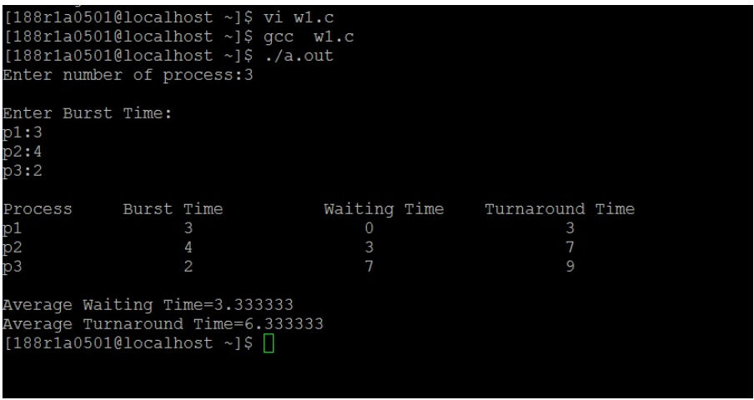

**2B.** **SHORTEST JOB FIRST SCHEDULING:**

#include<stdio.h>

int main()

{

int bt[20],p[20],wt[20],tat[20],i,j,n,total=0,pos,temp; float

avg_wt,avg_tat;

printf("Enter number of process:");

scanf("%d",&n);

printf("\nEnter Burst Time:\n");

for(i=0;i<n;i++)

{

printf("p%d:",i+1);

scanf("%d",&bt[i]);

p[i]=i+1; //contains process number

}

//sorting burst time in ascending order using selection sort

for(i=0;i<n;i++)

{

pos=i;

for(j=i+1;j<n;j++)

{

if(bt[j]<bt[pos])

pos=j;

}

temp=bt[i];

bt[i]=bt[pos];

bt[pos]=temp;

temp=p[i];

p[i]=p[pos];

p[pos]=temp;

}

wt[0]=0; //waiting time for first process will be zero

//calculate waiting time

for(i=1;i<n;i++)

{

wt[i]=0;

for(j=0;j<i;j++)

wt[i]+=bt[j];

total+=wt[i];

}

avg_wt=(float)total/n; //average waiting time

total=0;

printf("\nProcess\t Burst Time \tWaiting Time\tTurnaround Time");

for(i=0;i<n;i++)

{

tat[i]=bt[i]+wt[i]; //calculate turnaround time

total+=tat[i];

printf("\np%d\t\t %d\t\t %d\t\t\t%d",p[i],bt[i],wt[i],tat[i]);

}

avg_tat=(float)total/n; //average turnaround time

printf("\n\nAverage Waiting Time=%f",avg_wt);

printf("\nAverage Turnaround Time=%f\n",avg_tat);

}

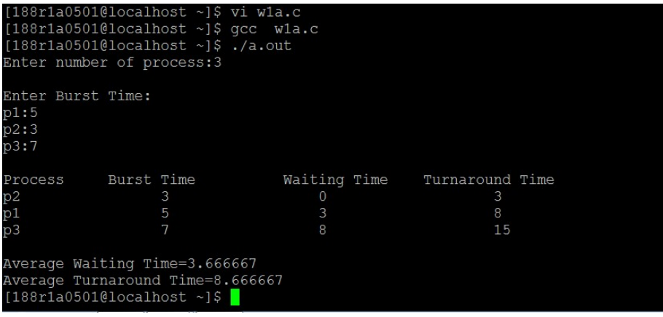

**2C.PRIORITY SCHEDULING:**

#include<stdio.h>

int main()

{

int bt[20],p[20],wt[20],tat[20],pri[20],i,j,k,n,total=0,pos,temp; float

avg_wt,avg_tat;

printf("Enter number of process:");

scanf("%d",&n);

printf("\nEnter Burst Time:\n");

for(i=0;i<n;i++)

{

printf("p%d:",i+1);

scanf("%d",&bt[i]);

p[i]=i+1;

}

printf(" enter priority of the process ");

for(i=0;i<n;i++)

{

p[i] = i;

printf("p%d ",i+1);

scanf("%d",&pri[i]);

}

for(i=0;i<n;i++)

for(k=i+1;k<n;k++)

if(pri[i] > pri[k])

{

temp=p[i];

p[i]=p[k];

p[k]=temp;

temp=bt[i];

bt[i]=bt[k];

bt[k]=temp;

temp=pri[i];

pri[i]=pri[k];

pri[k]=temp;

}

wt[0]=0;

for(i=1;i<n;i++)

{

wt[i]=0;

for(j=0;j<i;j++)

wt[i]+=bt[j];

total+=wt[i];

}

avg_wt=(float)total/n;

total=0;

printf("\nProcess\t Burst Time \tPriority \tWaiting Time\tTurnaround Time");

for(i=0;i<n;i++)

{

tat[i]=bt[i]+wt[i];

total+=tat[i];

printf("\np%d\t\t %d\t\t %d\t\t %d\t\t\t%d",p[i],bt[i],pri[i],wt[i],tat[i]);

}

avg_tat=(float)total/n;

printf("\n\nAverage Waiting Time=%f",avg_wt);

printf("\nAverage Turnaround Time=%f\n",avg_tat);

}

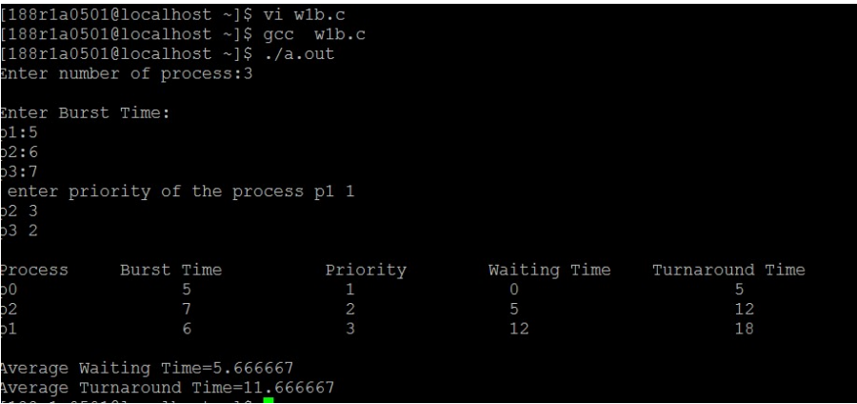

**2D.ROUND ROBIN SCHEDULING:**

#include<stdio.h>

main()

{

int st[10],bt[10],wt[10],tat[10],n,tq; int

i,count=0,swt=0,stat=0,temp,sq=0;

float awt,atat;

printf("enter the number of processes");

scanf("%d",&n);

printf("enter the burst time of each process /n");

for(i=0;i<n;i++)

{

printf(("p%d",i+1);

scanf("%d",&bt[i]);

st[i]=bt[i];

}

printf("enter the time quantum");

scanf("%d",&tq);

while(1)

{

for(i=0,count=0;i<n;i++)

{

temp=tq;

if(st[i]==0)

{

count++;

continue;

}

if(st[i]>tq)

st[i]=st[i]-tq;

else

if(st[i]>=0)

{

temp=st[i];

st[i]=0;

}

sq=sq+temp;

tat[i]=sq;

}

if(n==count)

break;

}

for(i=0;i<n;i++)

{

wt[i]=tat[i]-bt[i];

swt=swt+wt[i];

stat=stat+tat[i];

}

awt=(float)swt/n;

atat=(float)stat/n;

printf("process no\t burst time\t waiting time\t turnaround time\n");

for(i=0;i<n;i++)

printf("%d\t\t %d\t\t %d\t\t %d\n",i+1,bt[i],wt[i],tat[i]); printf("avg

wt time=%f,avg turn around time=%f",awt,atat);

}

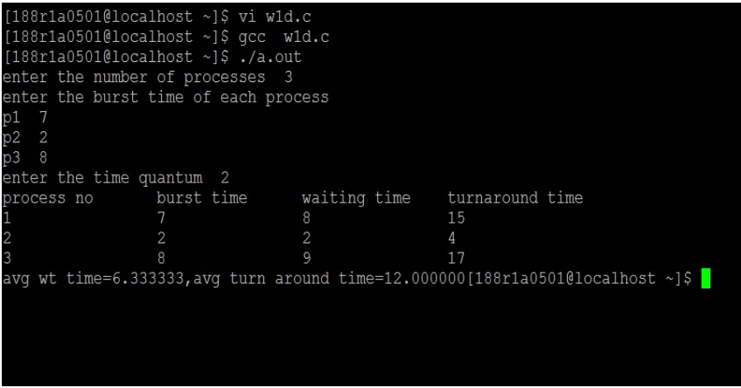

**3A .INTER PROCESS COMMUNICATIONS:**

#include <stdio.h>

#include<stdlib.h>

#include<string.h>

#include<sys/types.h>

#include<sys/wait.h>

#include<unistd.h>

int main()

{

int fd[2],child; char a[10];

printf("\n Enter the string:");

scanf("%s",a);

pipe(fd);

child=fork();

if(!child)

{

close(fd[0]);

write(fd[1],a,5); wait(0);

}

else

{close(fd[1]);

read(fd[0],a,5);

printf("The string received from pipe is: %s",a);

}

return 0;

}

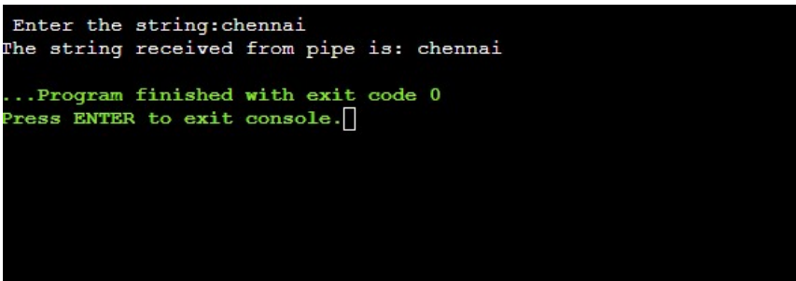

**3B. SYSTEM CALLS (READ & WRITE, CREATE &FORK, OPEN &CLOSE):**

#include <stdio.h>

#include<stdlib.h>

#include<string.h>

#include<sys/types.h>

#include<sys/wait.h>

#include<unistd.h>

#include<sys/stat.h>

#include<fcntl.h>

int main()

{

int n,i=0;

int f1,f2;

char c,strin[100];

f1=open("data",O_RDWR|O_CREAT|O_TRUNC);

while((c=getchar())!='\n')

{

strin[i++]=c;

}

strin[i]='\0';

write(f1,strin,i);

close(f1);

f2=open("data",O_RDONLY);

read(f2,strin,0);

printf("\n%s\n",strin);

close(f2);

fork();

return 0;

}

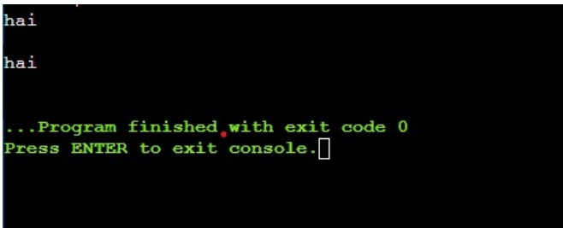

**3C. IMPLEMENT BANKERS’ ALGORITHM FOR DEAD LOCKAVOIDANCE:**

#include<stdio.h>

int main ()

{

int allocated[15][15], max[15][15], need[15][15],

avail[15], tres[15], work[15], flag[15];

int pno, rno, i, j, prc,

count, t, total; count =

0;

//clrscr ();

printf ("\n Enter number of

process:");

scanf ("%d", &pno);

printf ("\n Enter number

of resources:");

scanf ("%d", &rno);

for (i = 1; i <= pno; i++)

{

flag[i] = 0;

}

printf ("\n Enter total numbers of

each resources:");

for (i = 1; i <= rno; i++)

scanf ("%d", &tres[i]);

printf ("\n Enter Max resources for

each process:");

for (i = 1; i <= pno; i++)

{

printf ("\n for process %d:",

i);

for (j = 1; j <= rno; j++)

scanf ("%d", &max[i][j]);

}

printf ("\n Enter allocated resources for each

process:"); for (i = 1; i <= pno; i++)

{

printf ("\n for process %d:",

i); for (j = 1; j <= rno; j++)

scanf ("%d", &allocated[i][j]);

}

printf ("\n available

resources:\n");

for (j = 1; j <= rno; j++)

{

avail[j] = 0;

total = 0;

for (i = 1; i <= pno; i++)

{

total += allocated[i][j];

}

avail[j] =

tres[j] -

total;

work[j] =

avail[j];

printf (" %d \t", work[j]);

}

do

{

for (i = 1; i <= pno; i++)

{

for (j = 1; j <= rno; j++)

{

need[i][j] = max[i][j] - allocated[i][j];

}

}

printf ("\n Allocated matrix Max need");

for (i = 1; i <= pno; i++)

{

printf ("\n");

for (j = 1; j <= rno; j++)

{

printf ("%4d", allocated[i][j]);

}

printf ("|");

for (j = 1; j <= rno; j++)

{

printf ("%4d", max[i][j]);

}

printf ("|");

for (j = 1; j <= rno; j++)

{

printf ("%4d", need[i][j]);

}

}

prc = 0;

for (i = 1; i <= pno; i++){

if (flag[i] == 0){

prc = i;

for (j = 1; j <= rno; j++)

{

prc = 0; break;

}

if (work[j] < need[i][j])

{

}

}

if (prc != 0)

break;

}

if (prc != 0){

printf ("\n Process %d completed",

i);

count++;

printf ("\n Available

matrix:")

for (j = 1; j <= rno; j++)

{

work[j] +=

allocated[prc][

j];

allocated[prc][

j] = 0;

max[prc][j] = 0;

flag[prc] = 1;

printf (" %d", work[j]);

}

}

}

while (count != pno && prc != 0);

if (count == pno)

printf ("\nThe system is in a safe

state!!");

else

printf ("\nThe system is in an unsafe

state!!");

return 0;

}

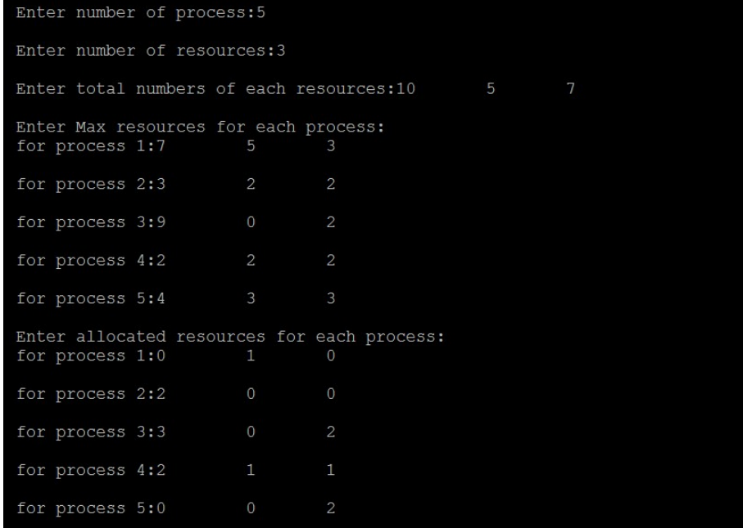

**4A. PAGING TECHNIQUE OF MEMORY**

**MANAGEMENT:**

#include<stdio.h>

int main()

{

int ms, ps, nop, np, rempages, i, j, x, y, pa, offset;

int s[10], fno[10][20];

printf("\nEnter the memory size -- ");

scanf("%d",&ms);

printf("\nEnter the page size -- ");

scanf("%d",&ps);

nop = ms/ps;

printf("\nThe no. of pages available in memory are -- %d ",nop);

printf("\nEnter number of processes -- ");

scanf("%d",&np);

rempages = nop;

for(i=1;i<=np;i++)

{

printf("\nEnter no. of pages required for p[%d]-- ",i);

scanf("%d",&s[i]);

if(s[i] >rempages)

{

printf("\nMemory is Full");

break;

}

rempages = rempages - s[i];

printf("\nEnter pagetable for p[%d] --- ",i);

for(j=0;j<s[i];j++)

scanf("%d",&fno[i][j]);

}

printf("\nEnter Logical Address to find Physical Address ");

printf("\nEnter process no. and page number and offset -- ");

scanf("%d %d %d",&x,&y, &offset);

if(x>np || y>=s[i] || offset>=ps)

printf("\nInvalid Process or Page Number or offset");

else

{ pa=fno[x][y]*ps+offset;

printf("\nThe Physical Address is -- %d",pa);

}

}

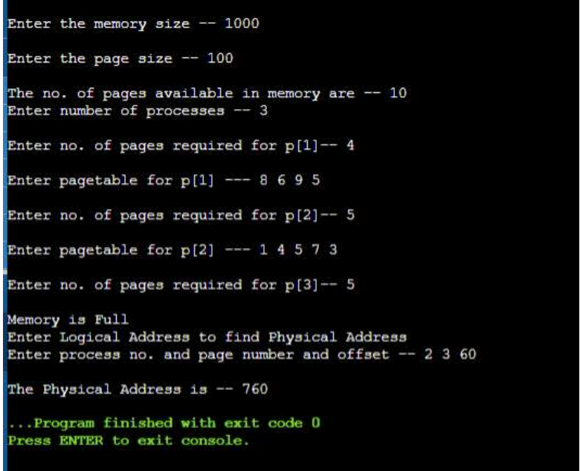

**4B. PAGE REPLACEMENTALGORITHM (FIFO):**

#include<stdio.h>

int main()

{

int i,j,n,a[50],frame[10],no,k,avail,count=0;

printf("\n ENTER THE NUMBER OF PAGES:\n");

scanf("%d",&n);

printf("\n ENTER THE PAGE NUMBER :\n");

for(i=1;i<=n;i++)

scanf("%d",&a[i]);

printf("\n ENTER THE NUMBER OF FRAMES :");

scanf("%d",&no);

for(i=0;i<no;i++)

frame[i]= -1;

j=0;

printf("\tRef string\t Page Frames\n");

for(i=1;i<=n;i++)

{

printf("%d\t\t\t",a[i]);

avail=0;

for(k=0;k<no;k++)

if(frame[k]==a[i])

avail=1;

if (avail==0)

{

frame[j]=a[i];

j=(j+1)%no;

count++;

for(k=0;k<no;k++)

printf("%d\t",frame[k]);

}

printf("\n");

}

printf("\nPage Fault Is %d",count);

return 0;

}

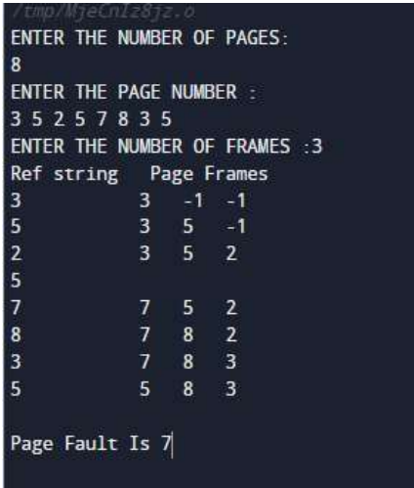

**4C.** **PAGE REPLACEMENTALGORITHM**

**(LRU):**

#include<stdio.h>

int main(){

int q[20],p[50],c=0,c1,d,f,i,j,k=0,n,r,t,b[20],c2[20];

printf("Enter no of pages: \n");

scanf("%d",&n);

printf("Enter the reference string: \n");

for(i=0;i<n;i++)

scanf("%d",&p[i]);

printf("Enter no of frames: \n");

scanf("%d",&f);

q[k]=p[k];

printf("\t\n\t %d\n",q[k]);

c++;

k++;

for(i=1;i<n;i++)

{

c1=0;

for(j=0;j<f;j++)

{

if(p[i]!=q[j])

c1++;

}

if(c1==f)

{

c++;

if(k<f)

{

q[k]=p[i];

k++;

for(j=0;j<k;j++)

printf("\t%d",q[j]);

printf("\n");

}

else

{

for(r=0;r<f;r++)

{

c2[r]=0;

for(j=i-1;j<n;j--)

{

if(q[r]!=p[j])

c2[r]++;

else

break;

}

}

for(r=0;r<f;r++)

b[r]=c2[r];

for(r=0;r<f;r++)

{

for(j=r;j<f;j++)

{

if(b[r]<b[j])

{

t=b[r];

b[r]=b[j];

b[j]=t;

}

}

}

for(r=0;r<f;r++)

{

if(c2[r]==b[0])

q[r]=p[i];

printf("\t%d",q[r]);

}

printf("\n");

}

}

}

printf("\nThe no of page faults is %d",c);

}

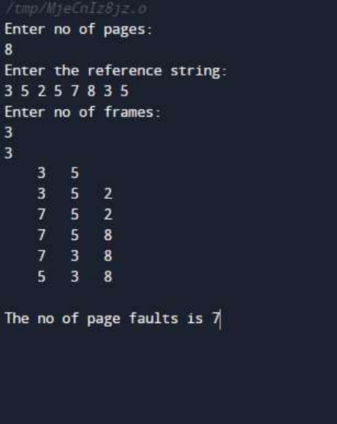

**4D. PAGE REPLACEMENT ALGORITHM**

**(OPR):**

#include<stdio.h>

int main()

{

int i,j,n,a[50],frame[10],no,k,avail,count=0;

printf("\n ENTER THE NUMBER OF PAGES:\n");

scanf("%d",&n);

printf("\n ENTER THE PAGE NUMBER :\n");

for(i=1;i<=n;i++)

scanf("%d",&a[i]);

printf("\n ENTER THE NUMBER OF FRAMES :");

scanf("%d",&no);

for(i=0;i<no;i++)

frame[i]= -1;

j=0;

printf("\tref string\t page frames\n");

for(i=1;i<=n;i++)

{

printf("%d\t\t",a[i]);

avail=0;

for(k=0;k<no;k++)

if(frame[k]==a[i])

avail=1;

if (avail==0)

{

frame[j]=a[i];

j=(j+1)%no;

count++;

for(k=0;k<no;k++)

printf("%d\t",frame[k]);

}

printf("\n");

}

printf("Page Fault Is %d",count);

return 0;

}

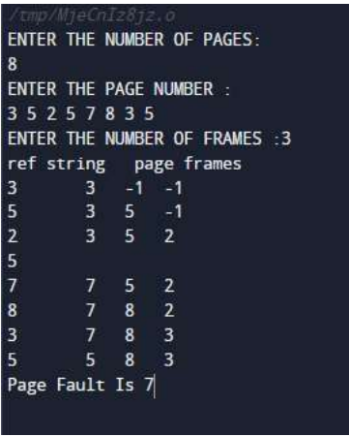

**5A. DISK SCHEDULING FIRST COME FIRST SERVE:**

#include <stdio.h>

#include <stdlib.h>

int main()

{

int RQ[100],i,n,TotalHeadMoment=0,initial;

printf ("Enter the number of Requests\n");

scanf("%d",&n);

printf("Enter the Requests sequence\n");

for(i=0;i<n;i++)

scanf("%d",&RQ[i]);

printf("Enter initial head position\n");

scanf("%d",&initial);

for(i=0;i<n;i++)

{

TotalHeadMoment=TotalHeadMoment+abs(RQ[i]-initial);

initial=RQ[i];

}

printf("Total head moment is %d",TotalHeadMoment);

return 0;

}

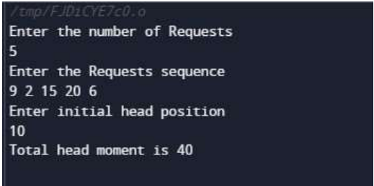

**5B. DISK SCHEDULING SHORTEST SEEK TIME FIRST:**

#include<stdio.h>

#include<stdlib.h>

int main()

{

int RQ[100],i,n,TotalHeadMoment=0,initial,count=0;

printf("Enter the number of Requests\n");

scanf("%d",&n);

printf("Enter the Requests sequence\n");

for(i=0;i<n;i++)

scanf("%d",&RQ[i]);

printf("Enter initial head position\n");

scanf("%d",&initial);

while(count!=n)

{

int min=1000,d,index;

for(i=0;i<n;i++)

{

d=abs(RQ[i]-initial);

if(min>d)

{

min=d;

index=i;

}

}

TotalHeadMoment=TotalHeadMoment+min;

initial=RQ[index];

RQ[index]=1000;

count++;

}

printf("Total head movement is %d",TotalHeadMoment);

return 0;

}

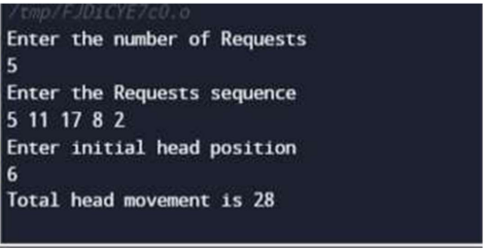

**5C. DISK SCHEDULING SCAN:**

#include<stdio.h>

#include<stdlib.h>

int main()

{

int RQ[100],i,j,n,TotalHeadMoment=0,initial,size,move;

printf("Enter the number of Requests\n");

scanf("%d",&n);

printf("Enter the Requests sequence\n");

for(i=0;i<n;i++)

scanf("%d",&RQ[i]);

printf("Enter initial head position\n");

scanf("%d",&initial);

printf("Enter total disk size\n");

scanf("%d",&size);

printf("Enter the head movement direction for high 1 and for low 0\n");

scanf("%d",&move);

for(i=0;i<n;i++)

{

for(j=0;j<n-i-1;j++)

{

if(RQ[j]>RQ[j+1])

{

int temp;

temp=RQ[j];

RQ[j]=RQ[j+1];

RQ[j+1]=temp;

}

}

}

int index;

for(i=0;i<n;i++)

{

if(initial<RQ[i])

{

index=i;

break;

}

}

if(move==1)

{

for(i=index;i<n;i++)

{

TotalHeadMoment=TotalHeadMoment+abs(RQ[i]-initial);

initial=RQ[i];

}

// last movement for max size

TotalHeadMoment=TotalHeadMoment+abs(size-RQ[i-1]-1);

initial = size-1;

for(i=index-1;i>=0;i--)

{

TotalHeadMoment=TotalHeadMoment+abs(RQ[i]-initial);

initial=RQ[i];

}

}

else

{

for(i=index-1;i>=0;i--)

{

TotalHeadMoment=TotalHeadMoment+abs(RQ[i]-initial);

initial=RQ[i];

}

TotalHeadMoment=TotalHeadMoment+abs(RQ[i+1]-0);

initial =0;

for(i=index;i<n;i++)

{

TotalHeadMoment=TotalHeadMoment+abs(RQ[i]-initial);

initial=RQ[i];

}

}

printf("Total head movement is %d",TotalHeadMoment);

return 0;

}

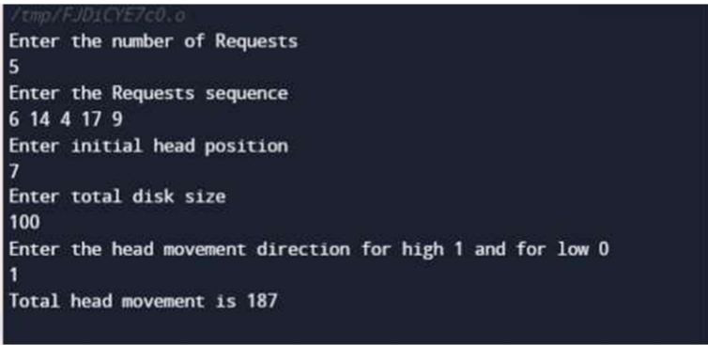

**5D. DISK SCHEDULING LOOK:**

#include<stdio.h>

#include<stdlib.h>

int main()

{

int RQ[100],i,j,n,TotalHeadMoment=0,initial,size,move;

printf("Enter the number of Requests\n");

scanf("%d",&n);

printf("Enter the Requests sequence\n");

for(i=0;i<n;i++)

scanf("%d",&RQ[i]);

printf("Enter initial head position\n");

scanf("%d",&initial);

printf("Enter total disk size\n");

scanf("%d",&size);

printf("Enter the head movement direction for high 1 and for low 0\n");

scanf("%d",&move);

for(i=0;i<n;i++)

{

for(j=0;j<n-i-1;j++)

{

if(RQ[j]>RQ[j+1])

{

int temp;

temp=RQ[j];

RQ[j]=RQ[j+1];

RQ[j+1]=temp;

}

}

}

int index;

for(i=0;i<n;i++)

{

if(initial<RQ[i])

{

index=i;

break;

}

}

if(move==1)

{

for(i=index;i<n;i++)

{

TotalHeadMoment=TotalHeadMoment+abs(RQ[i]-initial);

initial=RQ[i];

}

for(i=index-1;i>=0;i--)

{

TotalHeadMoment=TotalHeadMoment+abs(RQ[i]-initial);

initial=RQ[i];

}

}

else

{

for(i=index-1;i>=0;i--)

{

TotalHeadMoment=TotalHeadMoment+abs(RQ[i]-initial);

initial=RQ[i];

}

for(i=index;i<n;i++)

{

TotalHeadMoment=TotalHeadMoment+abs(RQ[i]-initial);

initial=RQ[i];

}

}

printf("Total head movement is %d",TotalHeadMoment);

return 0;

}

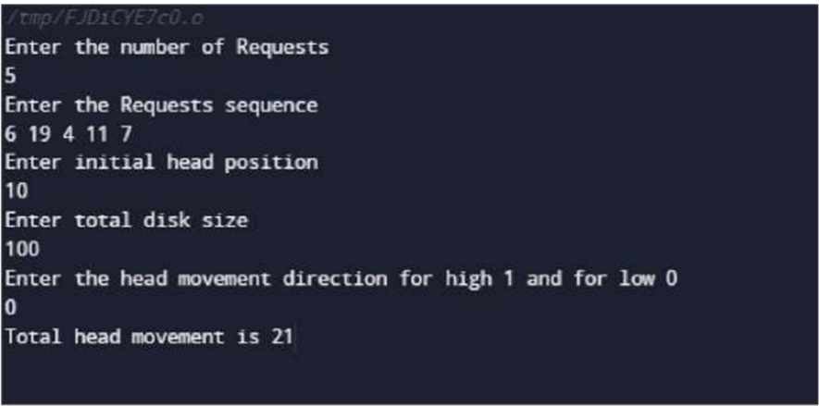

**6A. FILE MANAGEMENT USING SEQUENTIAL ALLOCATION:**

#include < stdio.h>

void main()

{

int f[50], i, st, len, j, c, k, count = 0;

clrscr();

for(i=0;i<50;i++)

f[i]=0;

printf("Files Allocated are : \n");

x: count=0;

printf(“Enter starting block and length of files: ”);

scanf("%d%d", &st,&len);

for(k=st;k<(st+len);k++)

if(f[k]==0)

count++;

if(len==count)

{

for(j=st;j<(st+len);j++)

if(f[j]==0)

{

f[j]=1;

printf("%d\t%d\n",j,f[j]);

}

if(j!=(st+len-1))

printf(” The file is allocated to disk\n");

}

else

printf(” The file is not allocated \n");

printf("Do you want to enter more file(Yes - 1/No - 0)");

scanf("%d", &c);

if(c==1)

goto x;

else

exit();

}

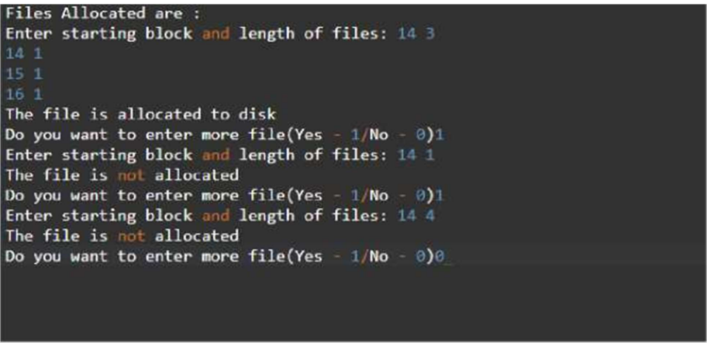

**6B. FILE MANAGEMENT USING INDEXED**

**ALLOCATION:**

#include<stdio.h>

#include<conio.h>

#include<stdlib.h>

void main()

{

int f[50], index[50],i, n, st, len, j, c, k, ind,count=0;

clrscr();

for(i=0;i<50;i++)

f[i]=0;

x:printf("Enter the index block: ");

scanf("%d",&ind);

if(f[ind]!=1)

{

printf("Enter no of blocks needed and no of files for the index %d on the disk : \n", ind);

scanf("%d",&n);

}

else

{

printf("%d index is already allocated \n",ind);

goto x;

}

y: count=0;

for(i=0;i<n;i++)

{

scanf("%d", &index[i]);

if(f[index[i]]==0)

count++;

}

if(count==n)

{

for(j=0;j<n;j++)

f[index[j]]=1;

printf("Allocated\n");

printf("File Indexed\n");

for(k=0;k<n;k++)

printf("%d ------- >%d : %d\n",ind,index[k],f[index[k]]);

}

else

{

printf("File in the index is already allocated \n");

printf("Enter another file indexed");

goto y;

}

printf("Do you want to enter more file(Yes - 1/No - 0)");

scanf("%d", &c);

if(c==1)

goto x;

else

exit(0);

getch();

}

